AWS-deploy wordpress with amazon RDS

Creat mysql database with RDS

Go to rds and creat

Select stranded creat and mysql engine

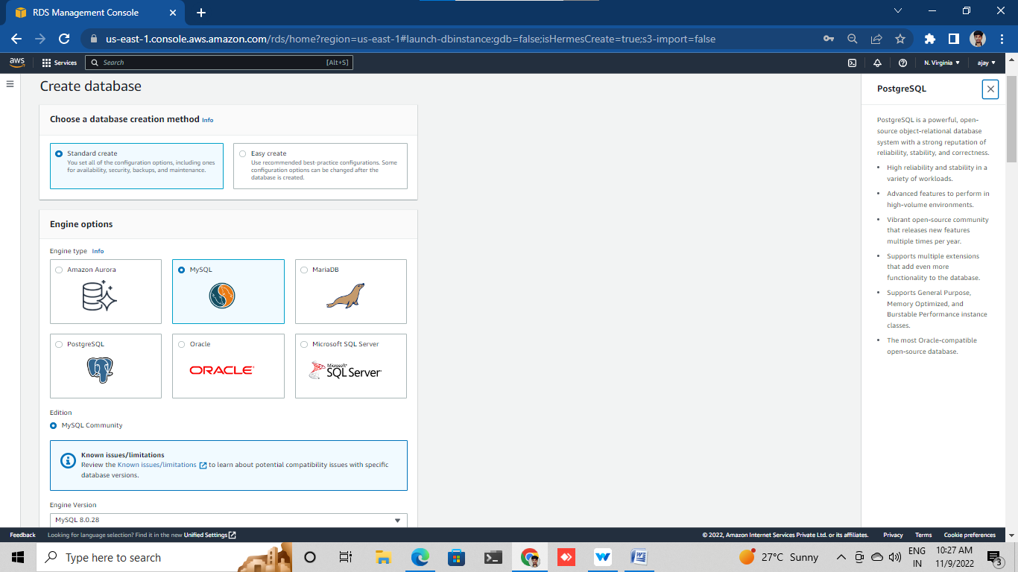

Creat password

Allowcated range 20

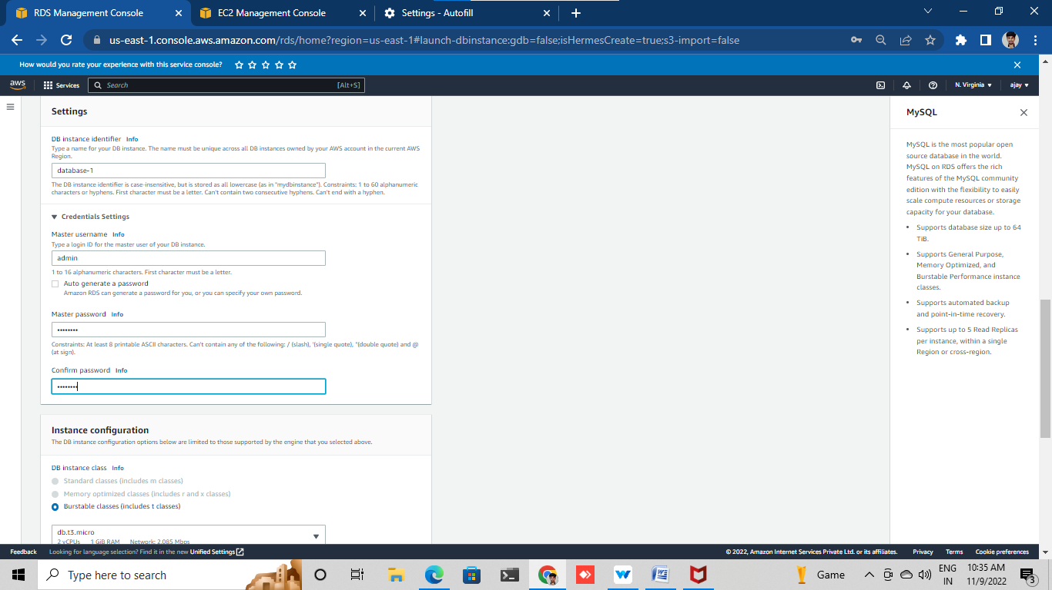

Creat mysql security group (port3306)

Exuit mysql sc group

DB permater version 5.7

Additional confg give DB name (wordpress)

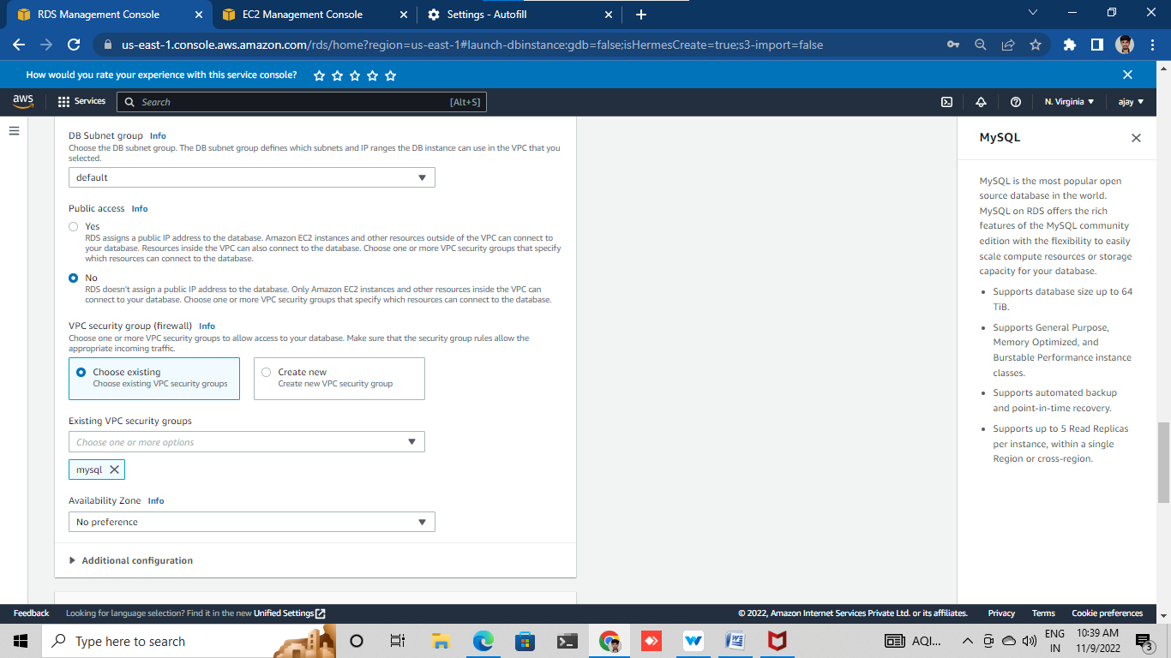

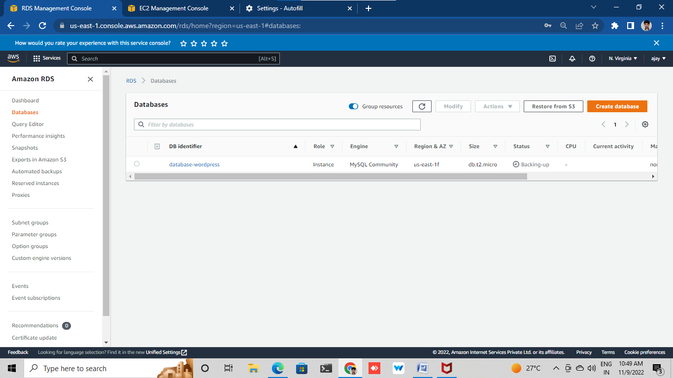

**Lab-2**

Creating a ec2 instance to run wordpress site

Go to aws console

Launch ec2 instance option in the top of right and click

Choose amazon linux ami free tire

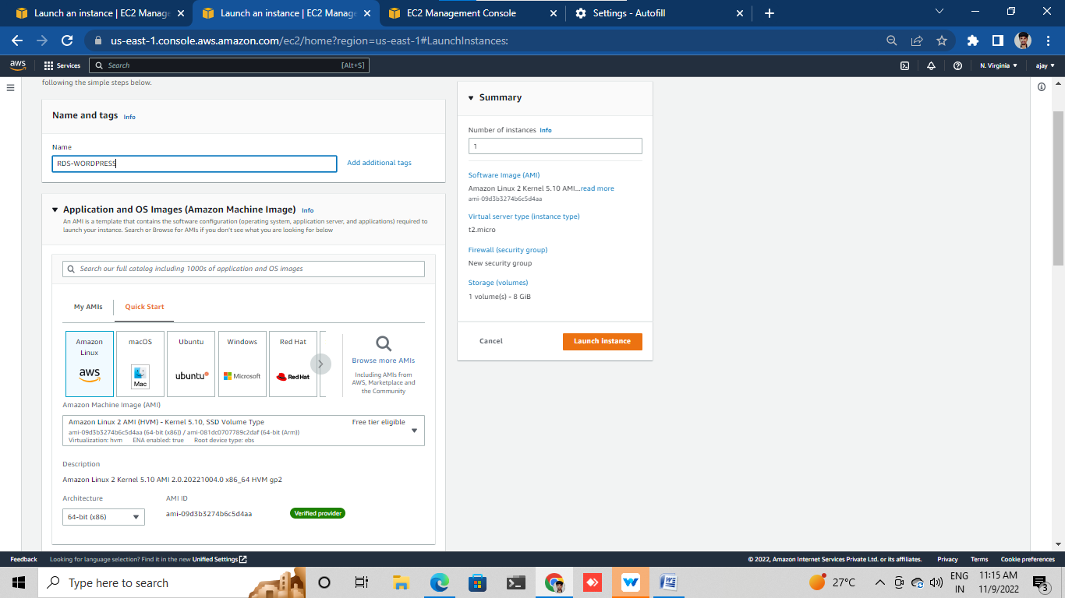

Choose an instance type t2.micro

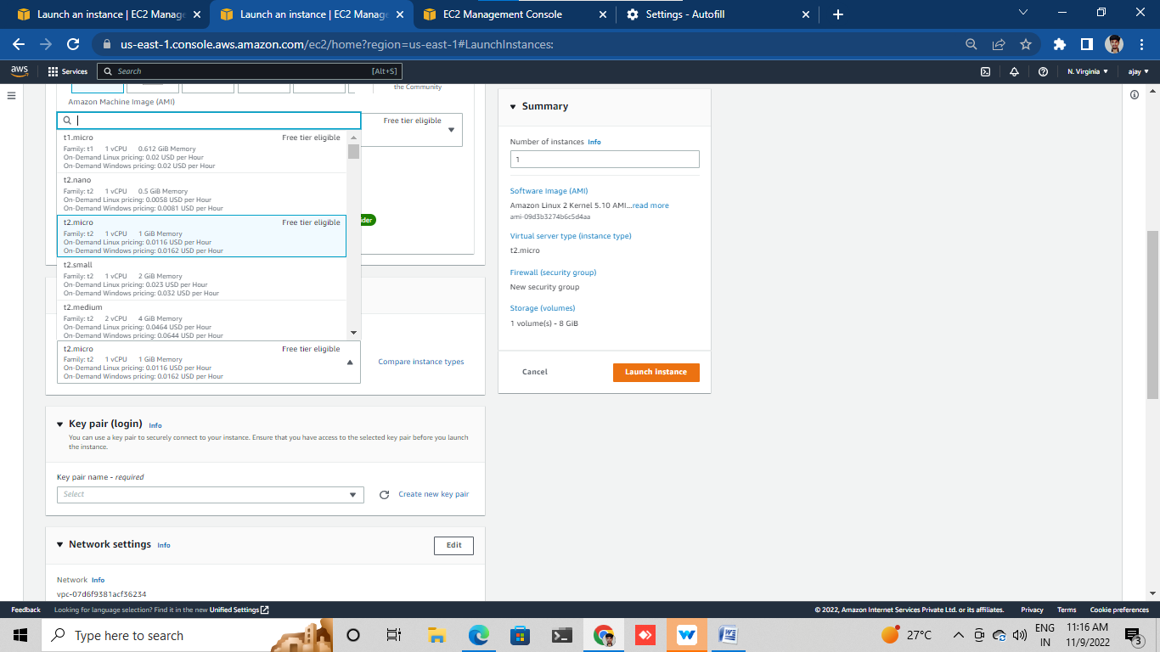

Confg security group

Creat http(80) use aneyware

Creat Ssh (22) use my ip

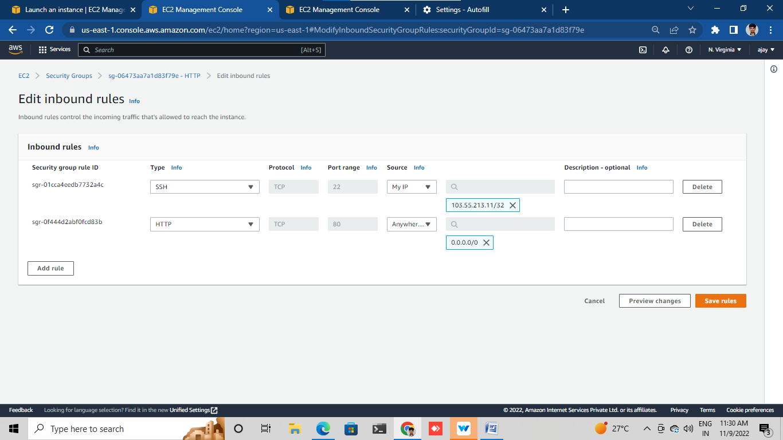

Select key pair or download key pair

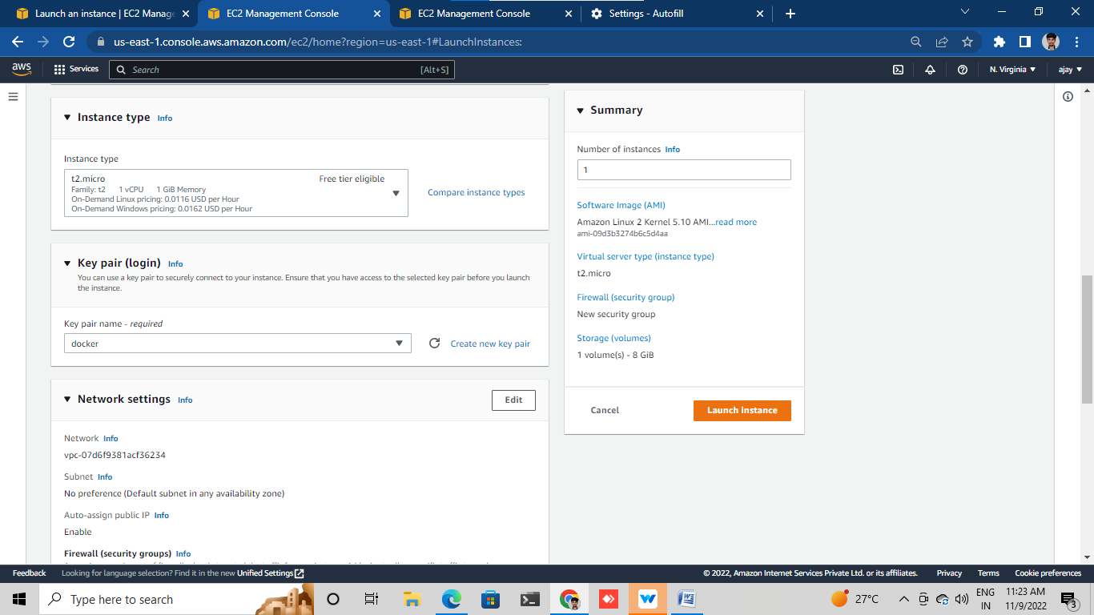

Click Launch instance

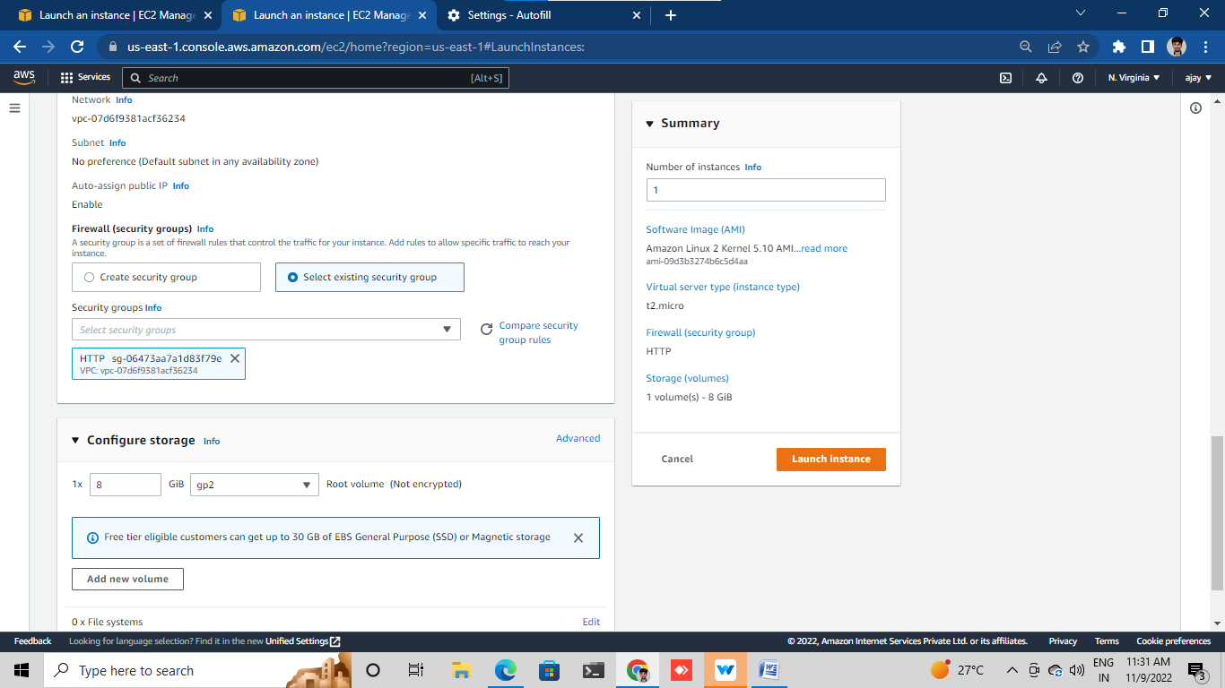

Lunched

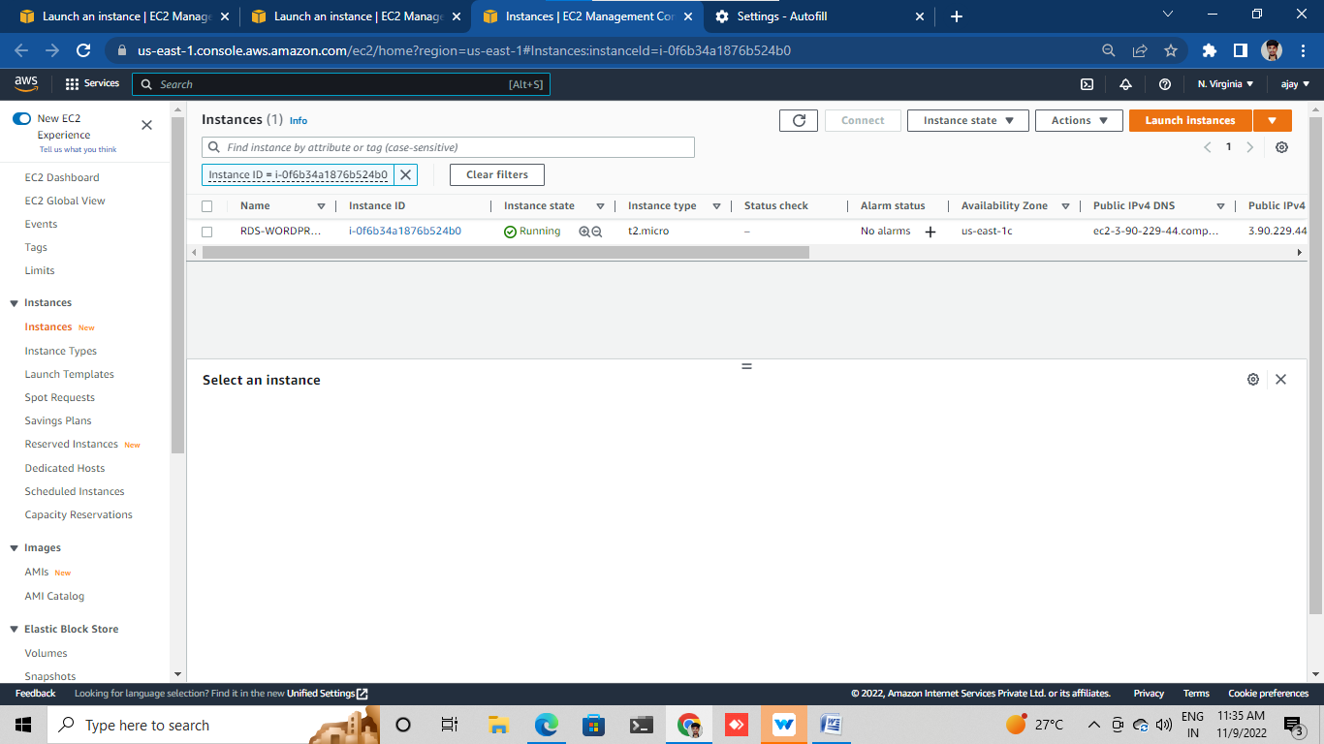

**LAB-3**

Confg your RDS database.

Go to RDS

Open which one have created

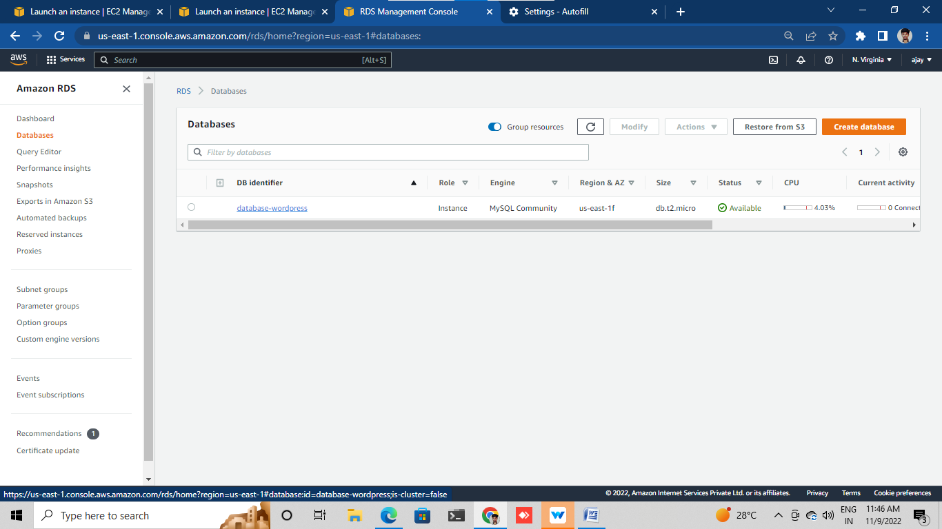click on the vpc security group

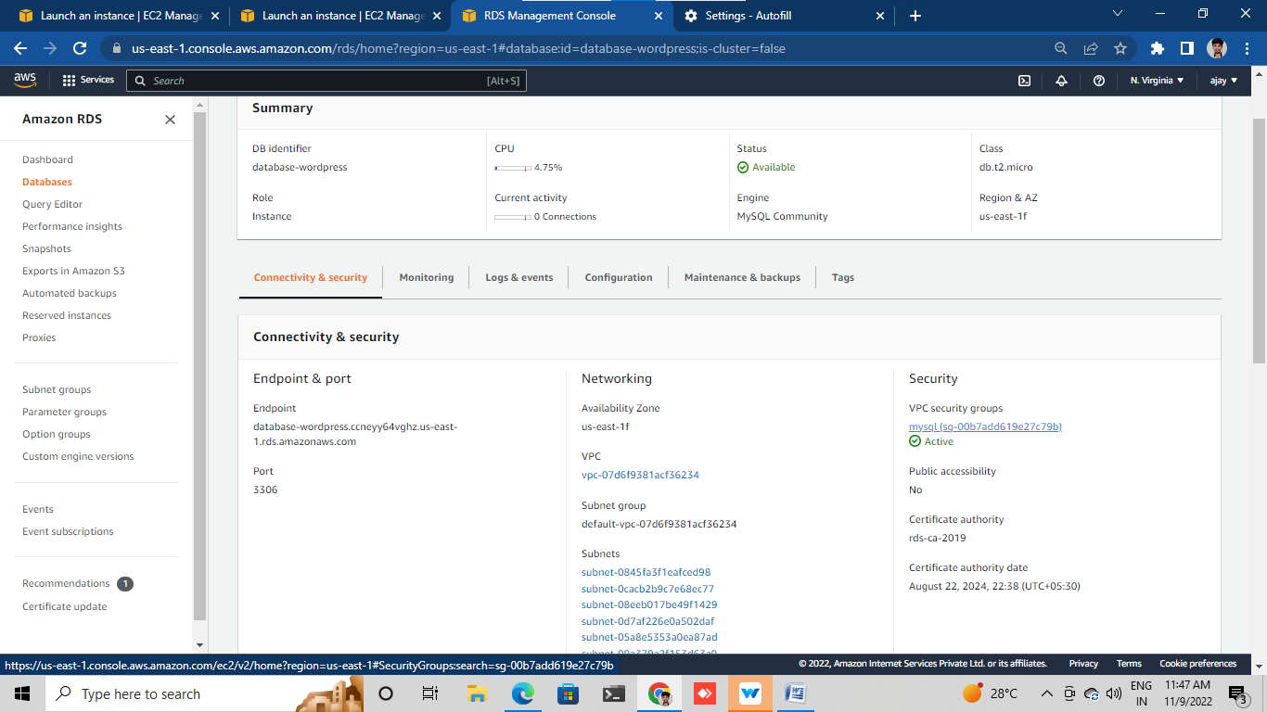

Click on inbound rules

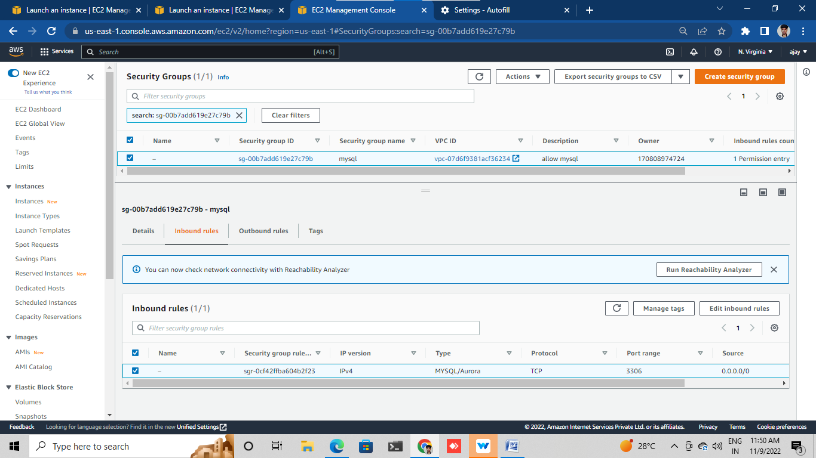

Click Edit inbound rules

assign tha wordpress ec2 intance security group

then save it

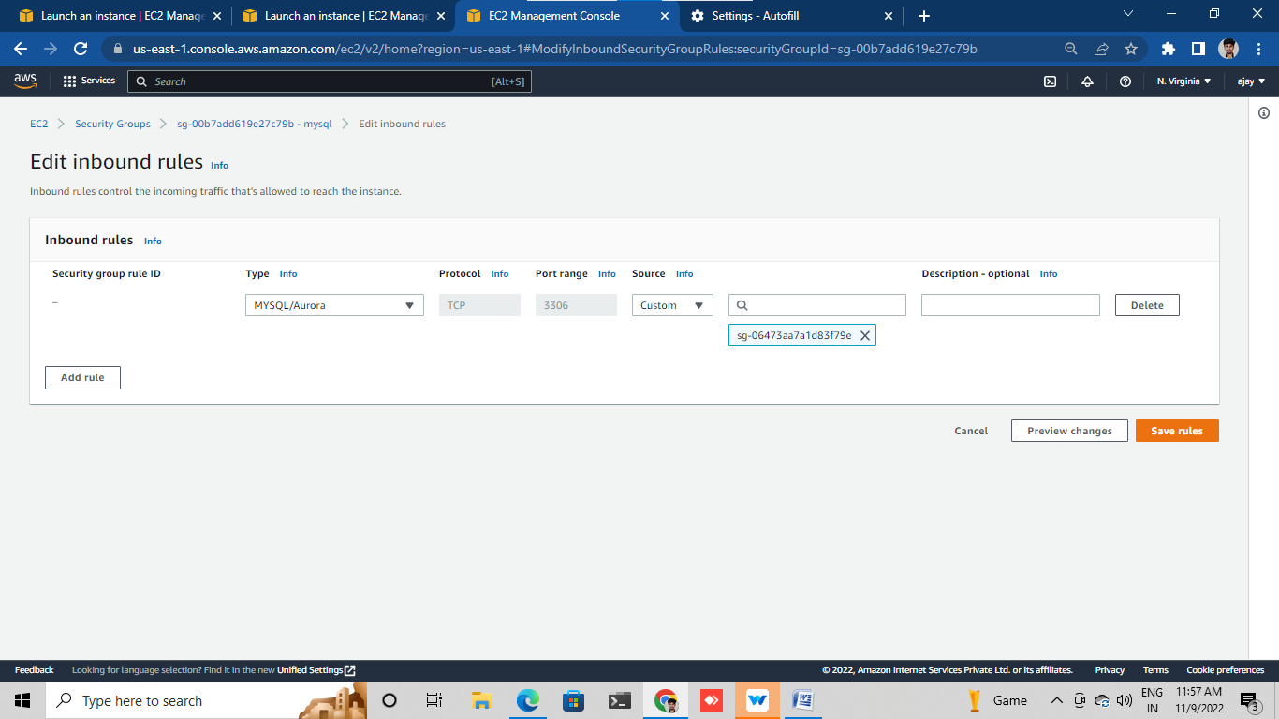

Then open instance list page

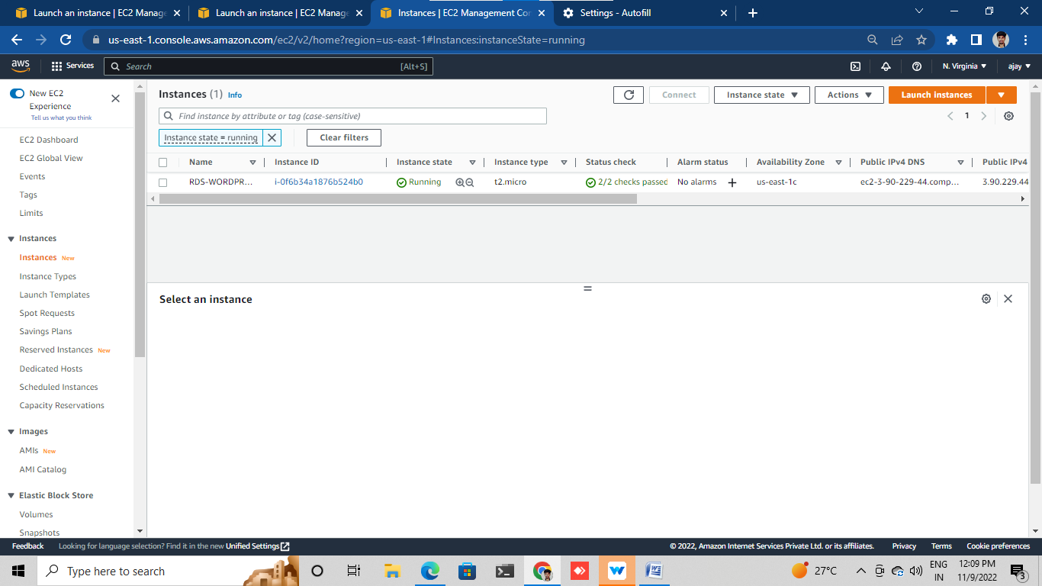

Select our instance

Copy pub ip

Open the terminal and use this command

*chmod 600 <path/to/pem/file>

* ssh i- <”path/to.pem/file”> ec2-user@<public ip dns>

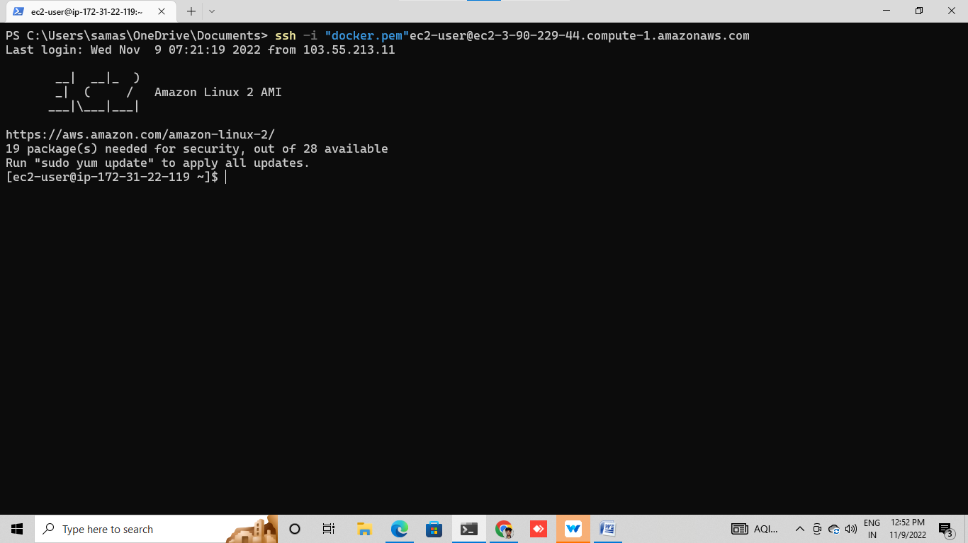

Install mysql in our terminal

Use this command –sudo yum –y install mysql

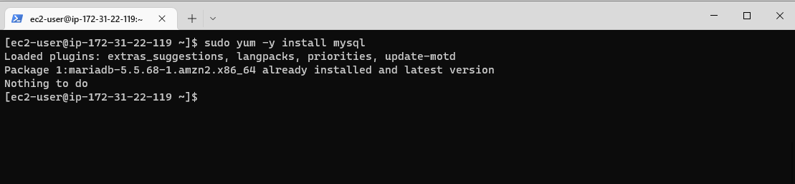

Then open your RDS

Go to connection &security

Then go to endpoint and select

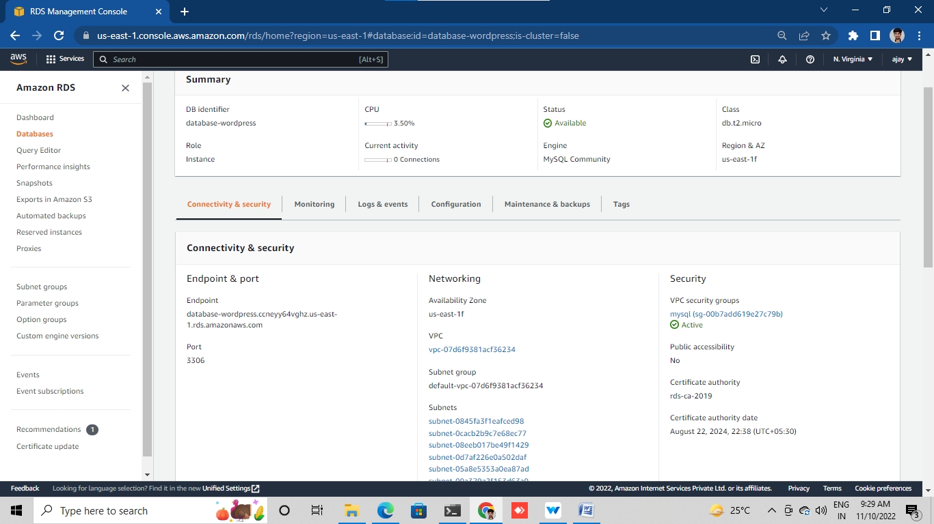

In our terminal use like this command

*export MYSQL_HOST=<YOUR RDS END POINT>

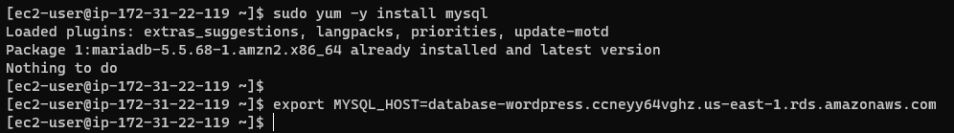

Then connect our DB use like this command

*Mysql --user=<user> --<password>=<password><word press>

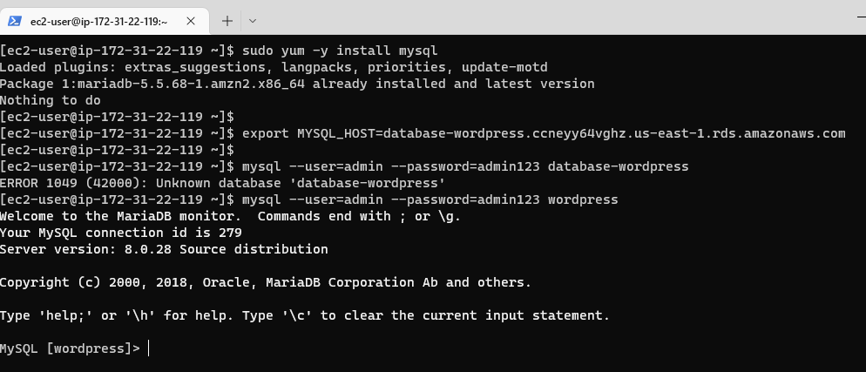run this command for give to identify “wordpress”database

*CREAT USER ‘wordpress’ IDENTIFIED BY ‘wordpress-pass’;

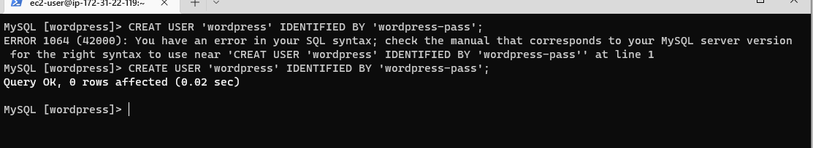

run this command for give to permission to access “wordpress”database

*GRAND ALL PRIVILEGES ON wordpress.TO wordpress;

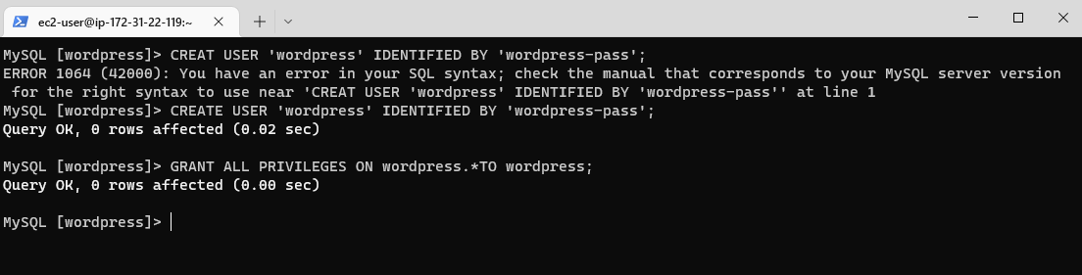

Run this command

*FLUSH PRIVILEGES;

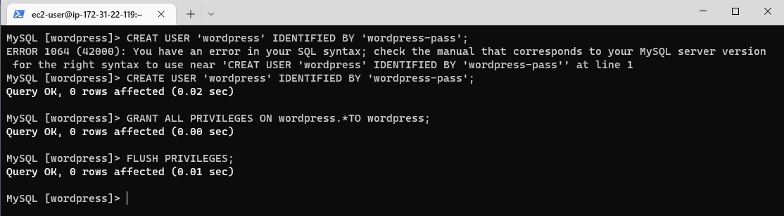

Then exit DB for use command

*EXIT

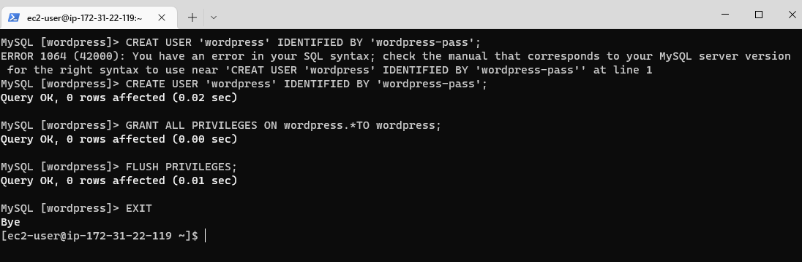

**LAB-4**

Follow this command in yur terminal for install apace web server

*Sudo yum –y install httpd

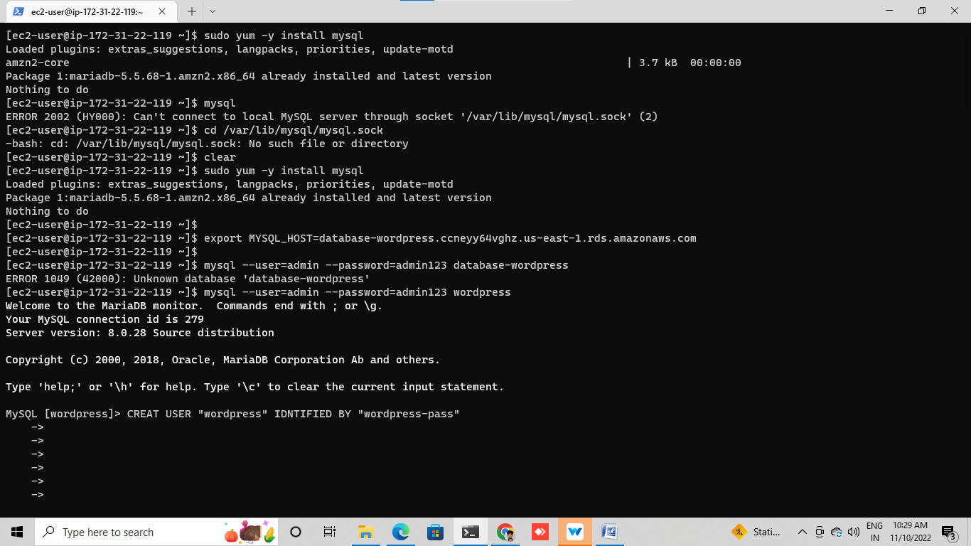

We have to start apace server by using this command

*sudo service httpd start

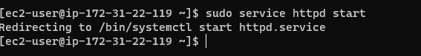

Brows through tha our instance public ip on tha google tab(pub pi+80) or public ipv4 dns

It will showing like apace test page

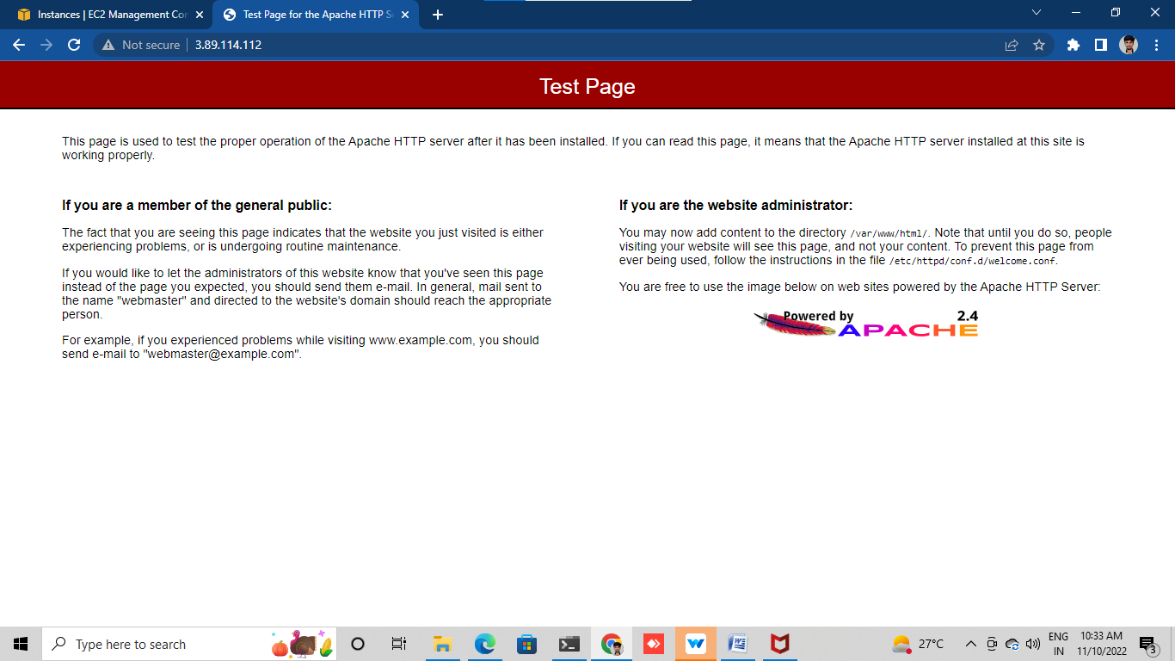

Below following commands we can download and confg the wordpress

*wget <https://wordpress.org/latest.tar.gz>

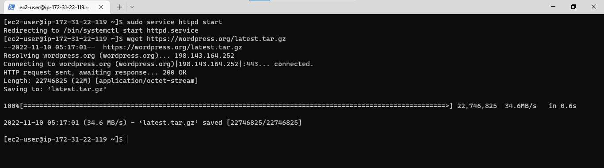

Then extract tha download file for using this command

*tar –xzf latest.tar.gz

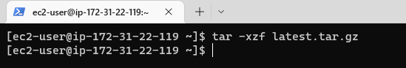

If want to see list content of directory use this command

*ls

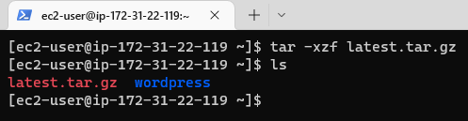

Change into wordpress file by using this command

*Cd wordpress/

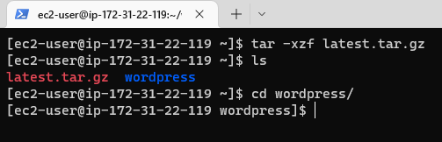

Creat a copy of the default confg file using this command

* cp wp –config-sample.php wp-config.php

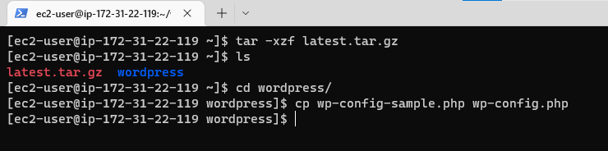

Then open the wp-config.php file by using vi editor for follow this command

*vi wp-config.php

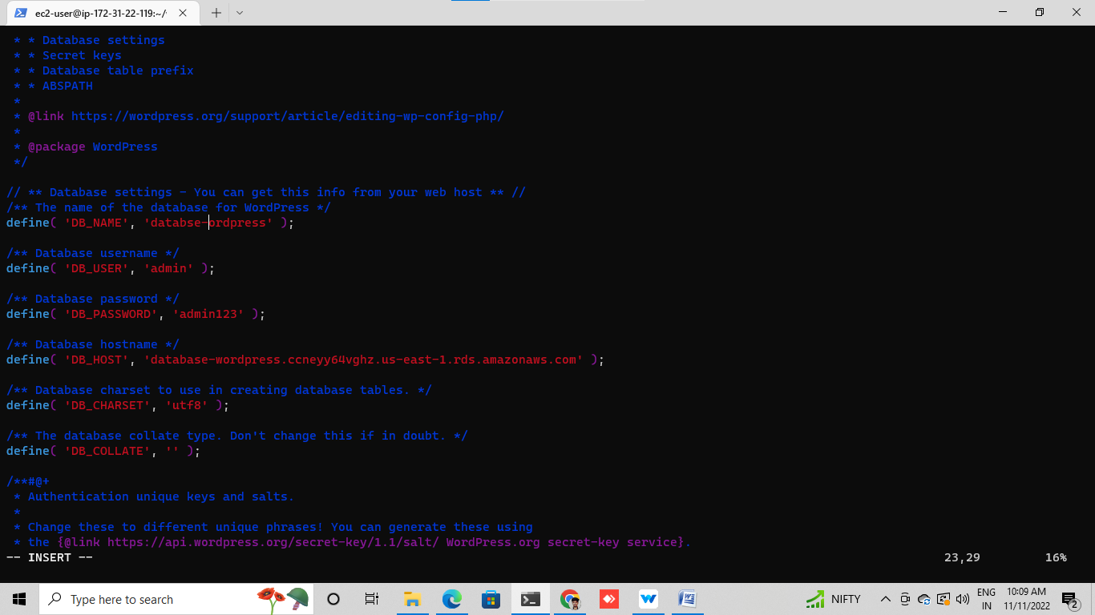

We should edit vi file like

Section-1

1 give a name of database

2 give a DB user id

3 give a DB password

4 give a end point od DB

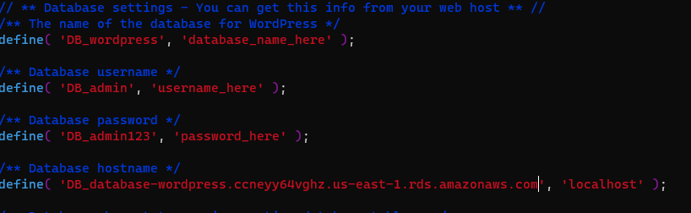

**Section-2**

Open this link (<https://api.wordpress.org/secret-key/1.1/salt/>)

it will generate values for config file

we have to config file from which we have link

paste in vi file

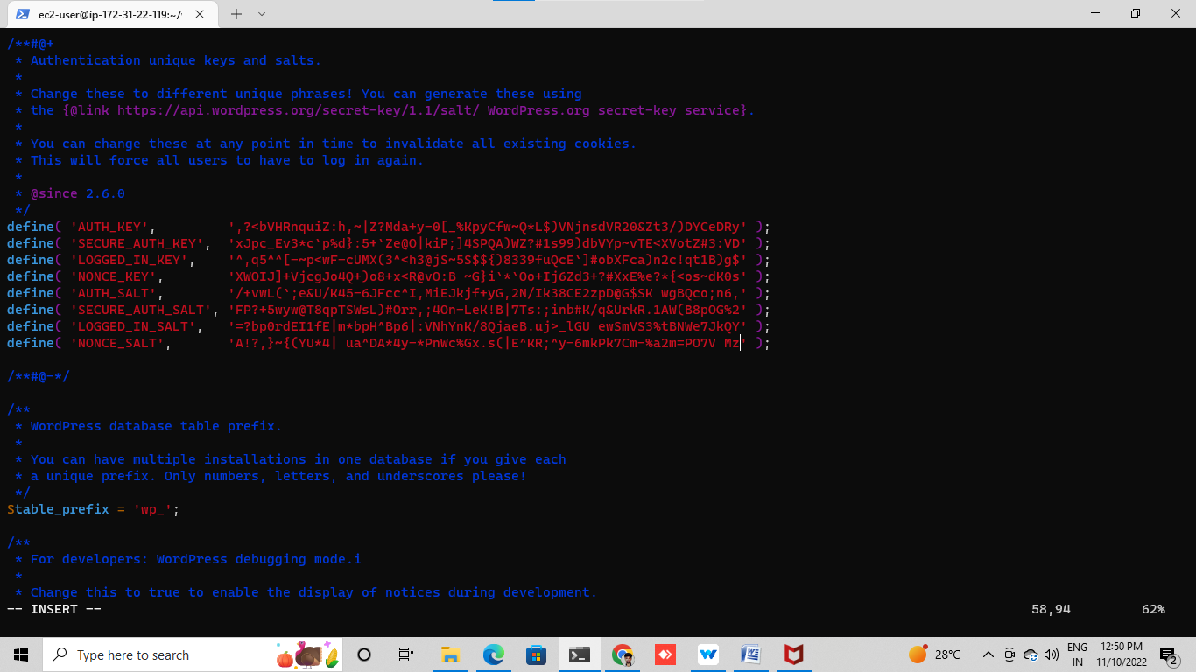

Then download then wordpress dependencies by using command

*sudo amazon-linux-extra install –y lamp –mariadb10.2-php7.2 php7.2

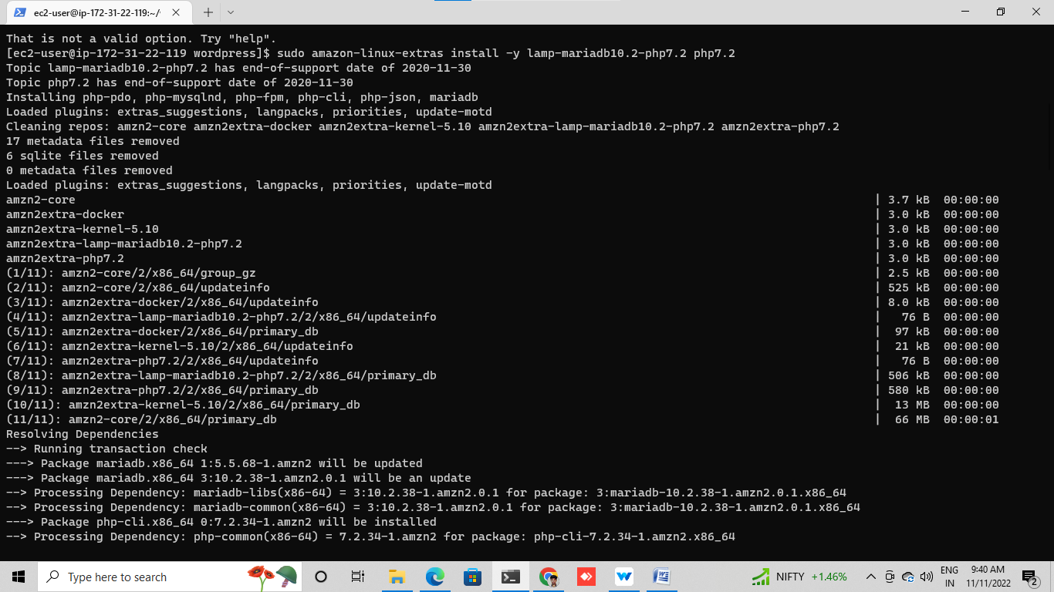

Second change to proper directory by using this command

*cd /home/ec2-user/

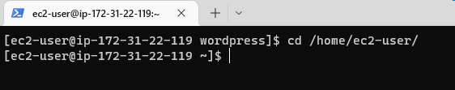

Then copy your wordpress application into /var/www/html/ directory use this command

*sudo cp –r wordpress /* /var/www/html/

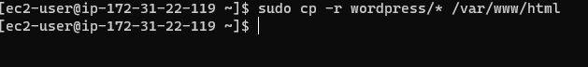

Then restart your httpd by using command

*sudo service httpd restart

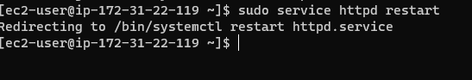

Open your google tab

paste your ec2 instance of pub ip ipv4 dns and search

it will show like wordpress web peage

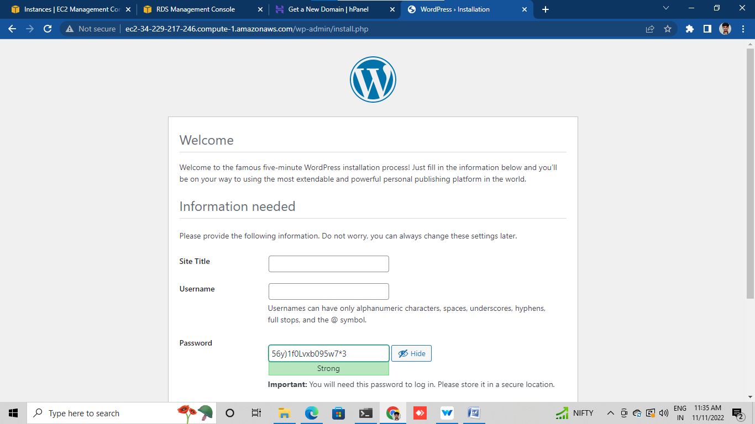

**LAB-5**

**Explore our new website and do clean up activity**

× Remove your ec2 instance or terminate your instance

Go to ec2 instance and select and termite

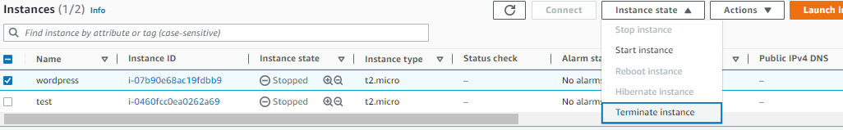

Delete your RDS

Goto RDS dashboard

Select and delete

